Comments on Developments in the Domain of the Carnegie Commission Task Force on Judicial and Regulatory Decision-Making
Gilbert S. Omenn, M.D.,Ph.D.

There are at least three notable developments, which warrant close examination and longterm encouragement:

1. The Framework for Environmental Health Risk Management, from the Presidential/Congressional Commission on Risk Assessment and Risk Management (1994-97). Reports are available at www.riskworld.com (1997).

The Commission developed a six-stage process, with two especially notable features: (a) putting each environmental health or ecological "problem" (whether arising from scientific reports, media coverage, or community observations-neighborhoods or tribal governments) into public health or ecologic CONTEXT; and (b) proactively engaging affected or potentially affected stakeholders from the start.

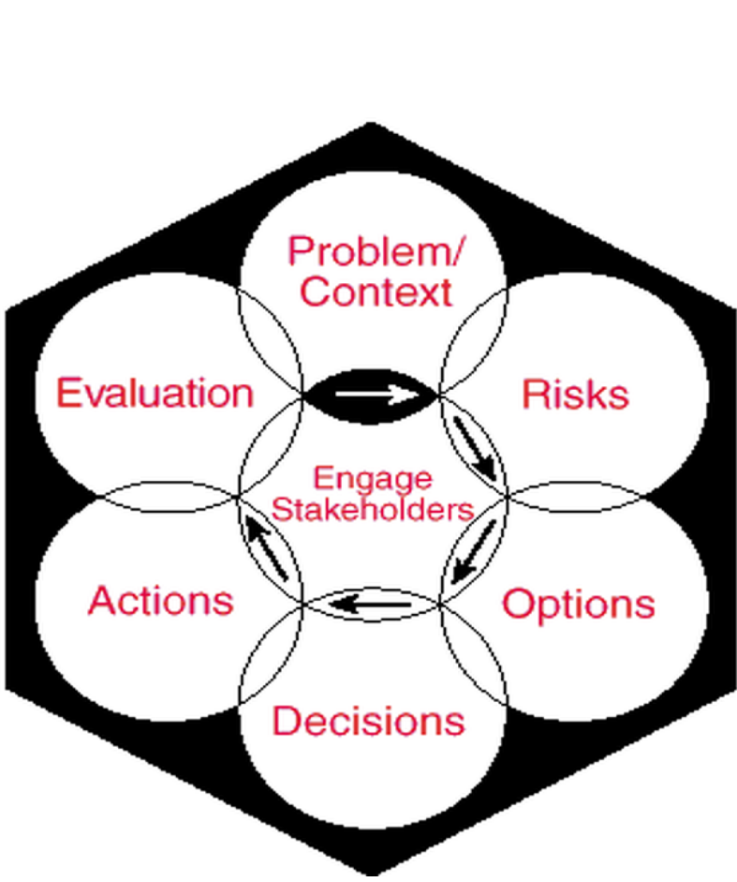The six stages are shown in the hexagon inserted below:

Putting problems into context involves:
a. Multiple sources of same chemical
b. Multiple media/pathways of exposure to same chemical
c. Other causes of same endpoint(s) (attributable fraction)
d. Multiple effects of same chemical.

Another key point was the recommendation that EPA and other agencies recognize a category of chemicals for whom sufficient knowledge of mechanism of action permits declaring them carcinogenic in rodents but not carcinogenic (or "not likely to be carcinogenic") in humans. This recommendation was adopted by the EPA in its 1996 proposed revision of its Carcinogenicity Testing Guidelines.

2. Criteria for Admissibility of Scientific Evidence and Scientific Expert Witness in the Courtroom: the Daubert case of 1993.

Carnegie Commission deliberations and participants played key roles in the development of a credible basis for the Supreme Court to issue criteria for judges to determine witnesses had the appropriate credentials to be recognized as "expert witnesses" and whether evidence claimed to be "scientific" met appropriate minimal tests of having been developed with generally-acknowledged scientific methods and was relevant to the issues in the case at hand.

The Daubert case itself involved the claims of human health risks from Bendectin, a very commonly used nausea-controlling medication for pregnant women.

A recent application of the Daubert rule occurred in Judge Blake's U.S. District Court in Baltimore in the case of Newman v Motorola and many other manufacturers and sellers of cellular telephones. After review of an extensive record, Judge Blake ruled that the evidence did not meet the Daubert criteria for consideration of the plaintiff's claim that his brain tumor could be attributed to his use of a personal cell phone.

3. Assistance to Judges in Cases with Particularly Complex Scientific and Technological Issues

Following recommendations from the Carnegie Commission Task Force, the Federal Judicial Center and the American Association for the Advancement of Science jointly developed a plan for identifying appropriate experts to serve as court-appointed masters or court-appointed experts. The AAAS project CASE, Court-Appointed Scientific Experts, was unveiled, after foundation funding was obtained, in about 1999. A broad array of scientific, medical, and engineering societies volunteered to assist the AAAS. CASE staff have responded to several requests from federal judges. There is an oversight committee which includes several members drawn from the original Carnegie Task Force. It would be appropriate to monitor this development.

Judges have had the authority under Federal Rule 706 to appoint/hire such expert assistance for many years. However, the practical issues of identifying, recruiting, and utilizing such individuals in timely fashion and with cooperation from the opposing attorneys have greatly impaired use of Rule 706. CASE overcomes some, but certainly not all, of these barriers.

Some of us will recall Judge (now Justice) Steve Breyer's comment that (roughly) "I have a simple solution for dealing with these complex cases---whether scientific, econometric, or psychological. I hire smart clerks!" We should note that Mr. Breyer then chose to devote his Oliver Wendell Holmes Lectures to matters of risks, especially health risks arising from environmental exposures. He participated actively in multiple S&T forums in the subsequent years, including the 150th anniversary celebration of the AAAS in Philadelphia.

